Sixteen p, Arial and bold letter for the title
Author One¹, Author Two²
¹Department of Electronic and Computer Engineering, The Hong Kong University of Science and Technology, Clear Water Bay, Kowloon, Hongkong, China
² Italic, 9 p, Times New Roman
¹woma2019@ust.hk
Abstract: The length of your abstract should be limited to 35 words. Use 10 p Times New Roman for the abstract. Margins should be set for a 2.54-cm top/bottom/left/right.

- Introduction
Please arrange the contents properly.
- Some details
2.1 Title
The title and subtitles for each section should be 10p Arial. The subtitle should be in Italic form [1].
2.2 Figures and tables
The figures should be of high resolution. Make sure that every figure is cited in the paper [1,2].
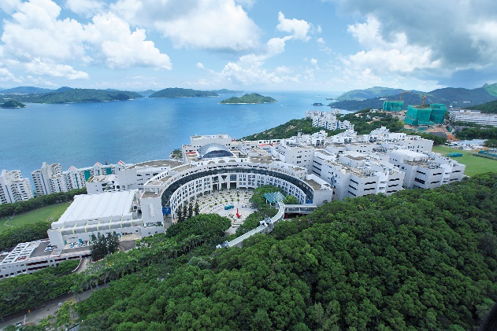
Fig. 1. HKUST campus. Use 8p Times New Roman.
Tables should use horizontal lines to delimit the top and bottom of the table and column headings. Make the tables simple for the readers to read [1-3].
Table 1. Bold 8p Times New Roman for table titles
Properties | A | B |  | C | D
Design 1 | 1 | 3 |  | 5 | 7
Design 2 | 2 | 4 |  | 6 | 8

- Summary
For any other details about the format that are not included in this template, please arrange them in a read-friendly way for your readers.
References
- Authors, “Title of paper,” Journal (year).

